**Databases Assignment**

**Group Number: 6G4Z0016**

**Tutor Name: Anthony Kleerekoper**

**Clint Paris (20051828)**

**David Tudorache (21302129)**

**Fadumo Farah (21440542)**

**Morgan Graves (21307114)**

**Table of Contents**

￼Section 1 - Executive Summary 2

Section 2: Database Design 3

2a - Top Down ERD 4

2b - Bottom Up ERD 5

2c - Merge of Top Down and Bottom Up ERD’s 5

Section 3: SQL Implementation 5

3a - Drop and Create Statements 5

3b - Insert Statements 5

3c – Screenshots of Insert Data 5

Section 4: Student Statements 5

Student A – Morgan Graves [21307114] 5

Student B – Clint Paris [20051828] 5

Student C – David Tudorache [21302129] 5

Student D – Fadumo Farah [21440542] 5

Appendix A: Individual ERD Attempts 5

Appendix B: Logbook 5

Logbook Entry 1 - 03/02/2022 5

Logbook Entry 2 - 10/02/2022 5

Logbook Entry 3 - 17/02/2022 5

Logbook Entry 4 22/02/22 5

Logbook Entry 5 - 24.02.2022 5

Logbook Entry 6 - 03/03/2022 5

Logbook Entry 7 [FINAL] - 10/03/2022 5

Attendance: 5

Appendix C: Full SQL Code 5

# Section 1 - Executive Summary

The purpose of this report is to show the development of a SQL database for the Mike’s Motorboat shop based of the various tables and information we were given about their company. To do this we had to determine the purpose of Mike’s Motorboats, which was to rent boats customers, as well as sell them to various dealers when the rental service no longer needed them.

This meant that the company had to keep track of the various customers, dealers, boats, boat parts, manufacturers of the boats and the maintenance history of all their boats. Because the company has used a paper-based system rather a digital one, this inevitably led to lots of disorganisation and errors, which ranged from the wrong information being stored to no information being stored. It was also more difficult for employees to pull up information about (for example) rental details, which led to more time taken for customers to rent/reserve any boats.

In this report we start off by designing the ERDs, both bottom-up and top-down, so that our team can have a rough idea of how we should design our database, including what entities would be necessary for our SQL database and what attributes would be a part of those entities. Then we normalised the data in our ERDs to produce a table with minimal repeated or irrelevant data and merged those with our finished ERD to make an effective plan of what our SQL database would look like. Finally, we coded the SQL database and inserted example data into the tables to make sure that the database was functional and effective.

# Section 2: Database Design

## 2a - Top Down ERD

**Draft 1:**

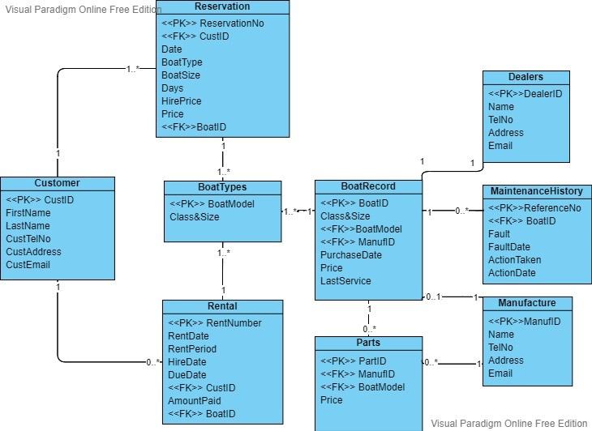

**Draft 2:**

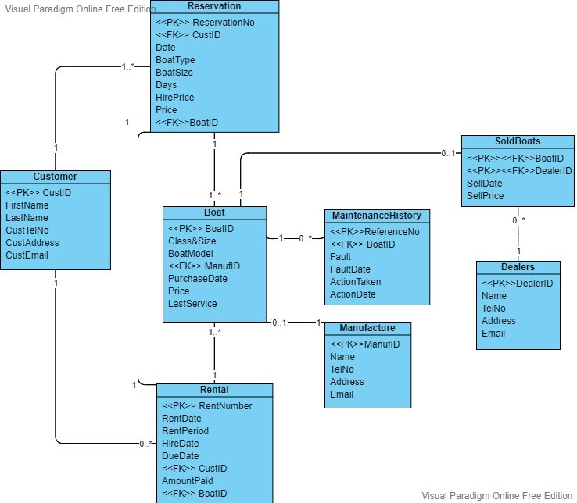  
**Final Group ERD:**

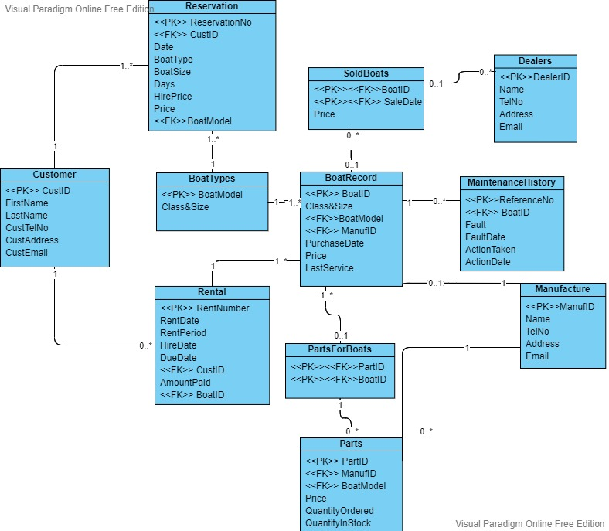

In the group top-down ERD, we discussed and concluded that majority of the entities and attributes remarkably similar and some to be the same. Resulting, in us to keep the Boat entity the main of the database project and thus allowing us to further work our way through the data. From the boat entity, we created the entities of rental and reservation, this is because the context document told us that once a reservation has been paid it is then turned into a rental, hence why they are two separate entities. The rental and reservation have a relationship with the customer entity, since each reservation must belong to a customer. This was discussed as we gathered that a customer cannot exist without at least a reservation, however, does not require a rental as the reservation may not have been paid off yet. Another entity that has a relationship with boat is the Maintenance History, there must be at least one boat for the maintenance history to exist, also our reasoning for our one to zero or many relationships is that we gathered a boat may have zero to multiple chances of maintenance to fixed boat parts etc. We also decided to include the manufacture entity from our individual ERD’s to store the separate contact information of the suppliers. We suggested to use a one to zero or one relationship as each boat has an individual ID, giving it a unique model and, it is also possible for a manufacture to supply a boat that has been sold and is no longer on the boat records, yet we must assume that the manufacture details are kept and stored even previously sold boats, allowing us to have a possible 1 to 0 relationship. Our last relationship we included is the sold boats entity as the context tells us that details on the sold boats are stored for 2 years, this is a one to zero or one relationship as each boat is individual so there cannot be many of the same individual boat. In addition, it is possible the boat has not been sold allowing a zero to one relationship to still occur. The sold boats entity does not have a unique attribute, therefore as a group we created a compound key using the foreign key from the boat entity and the dealer entity. Bringing us onto the last entity, “dealer entity”, the dealer entity stores information on dealers who can buy the sold boats. Information is stored about local dealers who might be interested; however, they may not have bought a boat or may have bought many leading to a one to zero or many relationships. We changed boat record to create a new entity called boat types, this is because customers could reverse a type of boat and not entirely an individual boat record. We also added a parts entity because we assumed its possible for the company to order boat parts from the manufacture for boats to be repaired.

## 2b - Bottom Up ERD

**Boat Record Normalisation**

|  |  |  |  |  |  |  |
| --- | --- | --- | --- | --- | --- | --- |
| 0NF |  | 1NF |  | 2NF |  | 3NF |
|  |  |  |  |  |  |  |
| BoatID |  | BoatID |  | BoatID |  | BoatID |
| HireDate |  | BoatType |  | BoatType |  | BoatType* |
| BoatType |  | BoatSize |  | BoatSize |  | PurchaseDate |
| BoatSize |  | BoatModel |  | BoatModel |  | PurchasePrice |
| DaysHired |  | PurchaseDate |  | PurchaseDate |  | SoldDate |
| HirePrice |  | PurchasePrice |  | PurchasePrice |  | SoldPrice |
| BoatModel |  | SoldDate |  | SoldDate |  |  |
| CustomerID |  | SoldPrice |  | SoldPrice |  | BoatType |
| CustomerName |  |  |  |  |  | BoatSize |
| CustomerContactDetails |  | BoatID |  | BoatID |  | BoatModel |
| RentalNo |  | RentalNo |  | RentalNo |  |  |
| ReservationNo |  | HireDate |  | HireDate |  | BoatID |
| DueDate |  | DaysHired |  | HirePrice |  | RentalNo |
| AmountPaid |  | HirePrice |  |  |  | HireDate |
| ManufactureID |  | DueDate |  | RentalNo |  | HirePrice |
| PurchaseDate |  |  |  | DaysHired |  |  |
| PurchasePrice |  | BoatID |  | DueDate |  | RentalNo |
| LastService |  | CustomerID |  |  |  | DaysHired |
| SoldDate |  | CustomerFirstName |  | CustomerID |  | DueDate |
| SoldPrice |  | CustomerLastName |  | CustomerFirstName |  |  |
| PartID |  | CustomerTelNo |  | CustomerLastName |  | CustomerID |
| PartPrice |  | CustomerEmail |  | CustomerTelNo |  | CustomerFirstName |
| QuantityOrdered |  | CustomerAddress |  | CustomerEmail |  | CustomerLastName |
| QuantityInStock |  |  |  | CustomerAddress |  | CustomerTelNo |
| DealerID |  | BoatID |  |  |  | CustomerEmail |
| DealerName |  | ReservationNo |  | BoatID |  | CustomerAddress |
| DealerContacts |  | ReservationPrice |  | ReservationNo |  |  |
| MaintenanceNo |  | AmountPaid |  | ReservationDate |  | BoatID |
| Fault |  | ReservationDate |  | ReservationPrice |  | ReservationNo |
| FaultDate |  |  |  |  |  | ReservationDate |
| NextServiceDate |  | BoatID |  | ReservationNo |  | ReservationPrice |
| ActionTaken |  | ManufactureID |  | AmountPaid |  |  |
| ActionDate |  | ManufactureName |  |  |  | ReservationNo |
| ManufactureContacts |  | ManufactureEmail |  | BoatID |  | AmountPaid |
|  |  | ManufactureTelNo |  | ManufactureID |  |  |
|  |  | ManufactureAddress |  | ManufactureName |  | BoatID |
|  |  |  |  |  |  | ManufactureID |
|  |  | BoatID |  | ManufactureID |  | ManufactureName |
|  |  | PartID |  | ManufactureEmail |  |  |
|  |  | PartPrice |  | ManufactureTelNo |  | ManufactureID |
|  |  | QuantityOrdered |  | ManufactureAddress |  | ManufactureEmail |
|  |  | QuantityInStock |  |  |  | ManufactureTelNo |
|  |  |  |  | PartID |  | ManufactureAddress |
|  |  | BoatID |  | PartPrice |  |  |
|  |  | DealerID |  | QuantityOrdered |  | PartID |
|  |  | DealerName |  | QuantityInStock |  | PartPrice |
|  |  | DealerTelNo |  |  |  | QuantityOrdered |
|  |  | DealerEmail |  | BoatID |  | QuantityInStock |
|  |  | DealerAddress |  | DealerID |  |  |
|  |  |  |  | DealerName |  | BoatID |
|  |  | BoatID |  |  |  | DealerID |
|  |  | MaintenanceNo |  | DealerID |  | DealerName |
|  |  | Fault |  | DealerTelNo |  |  |
|  |  | FaultDate |  | DealerEmail |  | DealerID |
|  |  | ActionTaken |  | DealerAddress |  | DealerTelNo |
|  |  | ActionDate |  |  |  | DealerEmail |
|  |  | LastService |  | BoatID |  | DealerAddress |
|  |  |  |  | MaintenanceNo |  |  |
|  |  |  |  | Fault |  | BoatID |
|  |  |  |  | LastService |  | MaintenanceNo |
|  |  |  |  |  |  | Fault |
|  |  |  |  | FaultDate |  | LastService |
|  |  |  |  | ActionTaken |  |  |
|  |  |  |  | ActionDate |  | FaultDate |
|  |  |  |  |  |  | ActionTaken |
|  |  |  |  |  |  | ActionDate |

**Merged 3NFs from Normalisations and Bottom Up Data Model**

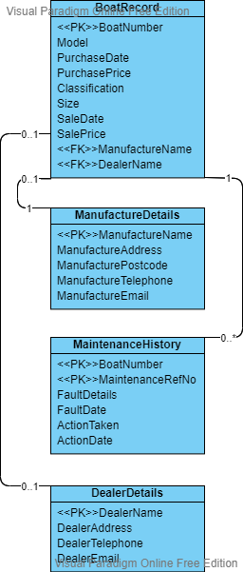

## 2c - Merge of Top Down and Bottom Up ERD’s

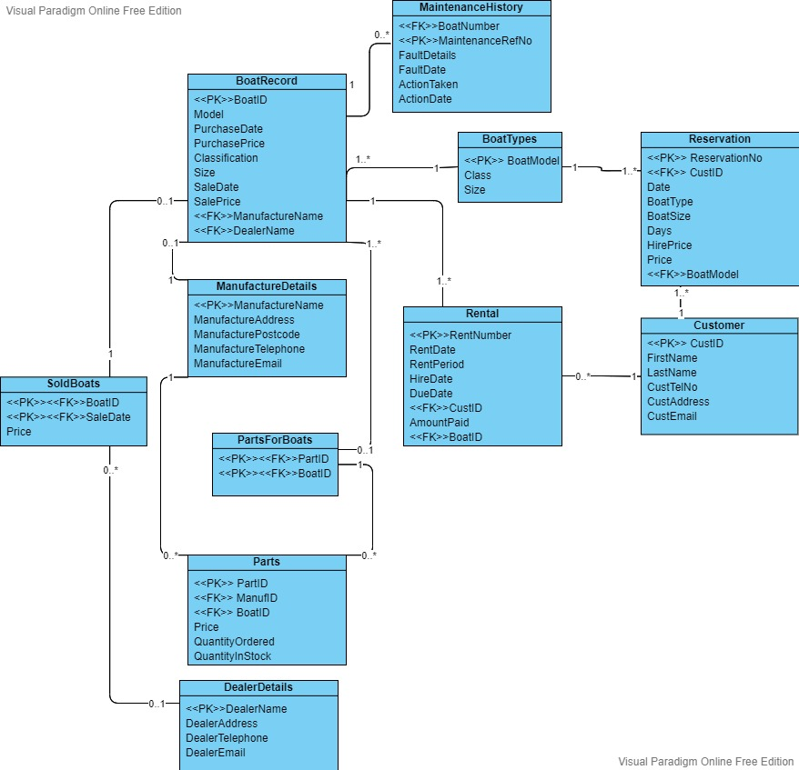

# Section 3: SQL Implementation

## 3a - Drop and Create Statements

DROP:

SET FOREIGN_KEY_CHECKS =0;

DROP TABLE emp;

DROP TABLE employees_teach;

DROP TABLE job_history;

DROP TABLE section;

DROP TABLE jobs;

DROP TABLE locations;

DROP TABLE regions;

DROP TABLE employees;

DROP TABLE departments;

DROP TABLE countries;

CREATE:

*CREATE TABLE ManufactureDetails (*

*ManufID decimal(5,0) PRIMARY KEY,*

*ManufNam varchar(50) ,*

*ManufTelNo decimal(11,0) ,*

*ManufAddress varchar(50) ,*

*ManufPostCode varchar(8) ,*

*ManufEmail varchar(50)*

*);*

*CREATE TABLE Dealers (*

*DealerName varchar(50) PRIMARY KEY,*

*DealerTelNo varchar(50),*

*DealerAddress longtext,*

*DealerEmail longtext*

*);*

*CREATE TABLE BoatRecord (*

*BoatID decimal(5,0) PRIMARY KEY,*

*Class_Size varchar(11) ,*

*BoatModel varchar(25) ,*

*ManufID decimal(5,0) ,*

*PurchDate date ,*

*PurchPrice decimal(6,2) ,*

*LastService date ,*

*DealerName varchar(25) ,*

*SaleDate date ,*

*SalePrice decimal(6,2) ,*

*FOREIGN KEY (ManufID) REFERENCES ManufactureDetails (ManufID),*

*FOREIGN KEY (DealerName) REFERENCES Dealers (DealerName)*

*);*

*CREATE TABLE MaintenanceHistory (*

*MaintID decimal(5,0) PRIMARY KEY,*

*BoatID decimal(5,0) ,*

*MaintRefNo decimal(5,0) ,*

*FaultDetails varchar(50) ,*

*FaultDate date ,*

*ActionTaken varchar(50) ,*

*ActionDate date ,*

*FOREIGN KEY (`BoatID`) REFERENCES BoatRecord (`BoatID`)*

*);*

*CREATE TABLE BoatTypes(*

*BoatModel VARCHAR(25) PRIMARY KEY,*

*Class VARCHAR(25),*

*Size VARCHAR(25),*

*Price DECIMAL(65)*

*);*

*CREATE TABLE Parts(*

*PartID INT PRIMARY KEY,*

*ManufID decimal(5,0),*

*BoatID decimal(5,0),*

*Price INT,*

*QuantityOrdered INT,*

*QuantityInStock INT,*

*FOREIGN KEY (BoatID) REFERENCES BoatRecord (BoatID),*

*FOREIGN KEY (ManufID) REFERENCES ManufactureDetails (ManufID)*

*);*

*CREATE TABLE PartsForBoats(*

*PartID INT,*

*BoatID decimal(5,0),*

*CONSTRAINT PRIMARY KEY(PartID, BoatID),*

*FOREIGN KEY (BoatID) REFERENCES BoatRecord (BoatID),*

*FOREIGN KEY (PartID) REFERENCES Parts (PartID)*

*);*

*CREATE TABLE Customer*

*(CustID DECIMAL(4) PRIMARY KEY,*

*FirstName VARCHAR(25),*

*LastName VARCHAR(25),*

*CustTelNo DECIMAL(11),*

*CustAddress VARCHAR(255),*

*CustEmail VARCHAR(255));*

*CREATE TABLE SoldBoats(*

*BoatID decimal(5,0),*

*saleDate DATE,*

*price VARCHAR(25),*

*CONSTRAINT PRIMARY KEY(boatID, saleDate),*

*FOREIGN KEY (BoatID) REFERENCES BoatRecord (BoatID)*

*);*

*CREATE TABLE rental(*

*rentNumber INT PRIMARY KEY,*

*rentDate DATE,*

*rentPeriod VARCHAR(10),*

*hireDate DATE,*

*dueDate DATE,*

*actualDate DATE,*

*amountPaid INT,*

*CustID DECIMAL(4),*

*BoatID decimal(5,0),*

*FOREIGN KEY (BoatID) REFERENCES BoatRecord (BoatID),*

*FOREIGN KEY (CustID) REFERENCES Customer (CustID)*

*);*

*CREATE TABLE reservation(*

*reservationNo DECIMAL(10) PRIMARY KEY,*

*CustID DECIMAL(4),*

*resDate DATE,*

*BoatType VARCHAR(25),*

*boatSize VARCHAR(6),*

*days DECIMAL(1),*

*hirePrice DECIMAL(10,2),*

*price DECIMAL(10),*

*boatNumber DECIMAL(2),*

*BoatModel VARCHAR(25),*

*FOREIGN KEY (CustID) REFERENCES Customer (CustID),*

*FOREIGN KEY (BoatModel) REFERENCES BoatTypes (BoatModel)*

*);*

## 3b - Insert Statements

*INSERT INTO Dealers(DealerName, DealerAddress, DealerTelNo, DealerEmail)*

*VALUES('Dalis Vannoort', '77 A828, Appin, AP7 6GU', 075731374643, '*[*dvannoort0@salon.com*](mailto:dvannoort0@salon.com)*');*

*INSERT INTO ManufactureDetails*

*VALUES(1,'SuperBoat',1772459666,'Unit 7 Centurion Court, Leyland','LE10* [*2DJ','admin@superboat.co.uk*](mailto:2DJ','admin@superboat.co.uk)*');*

*INSERT INTO BoatTypes(boatModel, class, size, price)*

*VALUES('VLSB', 'sail boat', 'very large', 240);*

*INSERT INTO Customer(CustID, FirstName, LastName, CustTelNo, CustAddress, CustEmail)*

*VALUES (1, 'Dion', 'Broadnecke', 07174826351, '9 Oak Street, Liverpool, L34 8DY', '*[*dbroes1d@who.int*](mailto:dbroes1d@who.int)*');*

*INSERT INTO reservation(reservationNo, custID, resDate, boatType, boatSize,days, hirePrice, boatNumber, boatModel)*

*VALUES(5344, 1, 20/10/2020, 'Rboat', 'Lrg', 1, 280, 9, 'LRB');*

*INSERT INTO BoatRecord*

*VALUES (1,'Std_MBoat','Explorer',1,'2010-11-22',3910.00,'2020-10-22','Dalis Vannoort','2020-01-02',1500.00);*

*INSERT INTO MaintenanceHistory*

*VALUES (1,1,1,'Chipped propeller','2015-02-15','Replace Propeller','2015-02-27');*

*INSERT INTO SoldBoats(boatID, saleDate, price)*

*VALUES('1', 30/11/2020, 1500);*

*INSERT INTO rental(rentNumber, rentDate, rentPeriod, hireDate, dueDate, actualDate, amountPaid, custID, boatID)*

*VALUES(4734, 02/05/19, 'HD', 02/05/19, 02/05/19, 02/05/19, 125,11, 1);*

## 3c – Screenshots of Insert Data

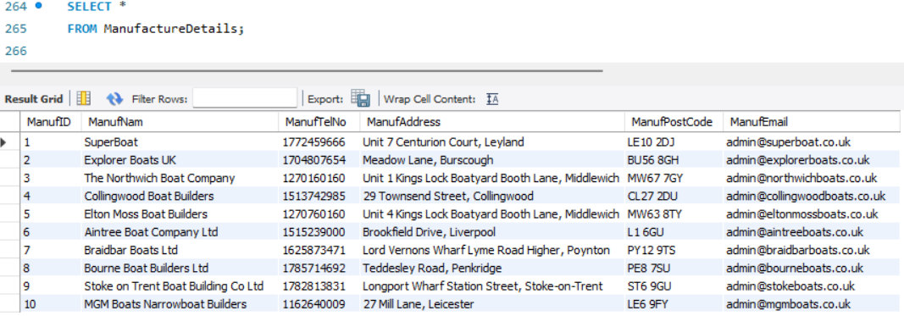

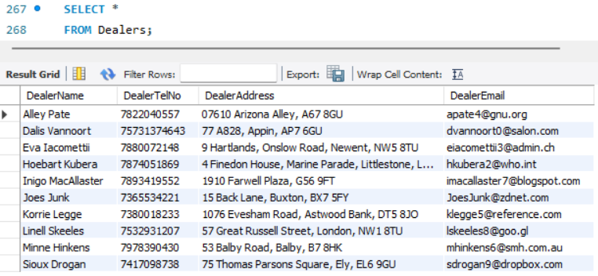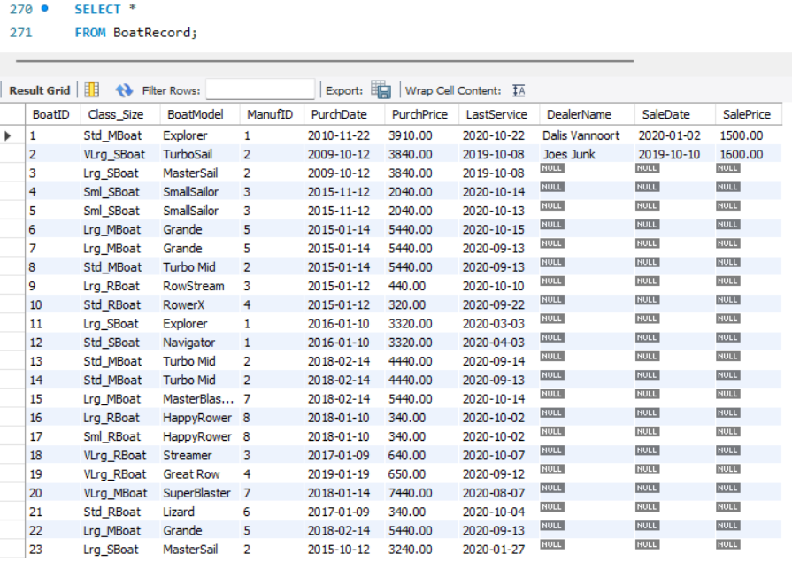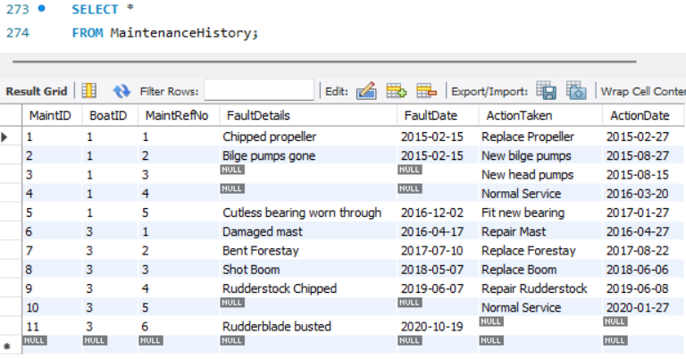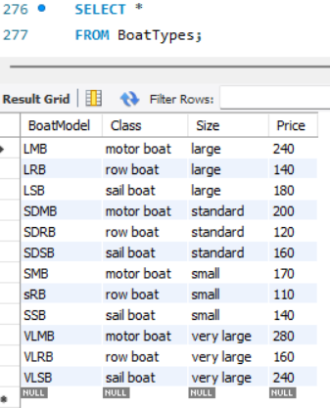

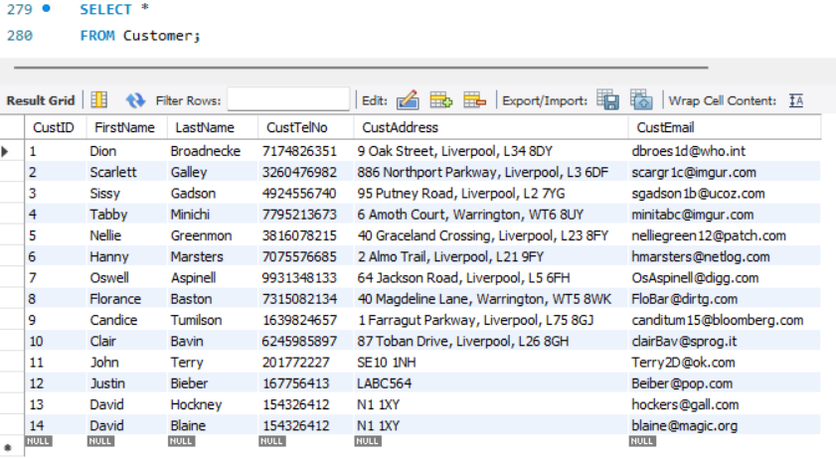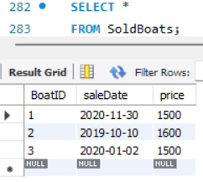

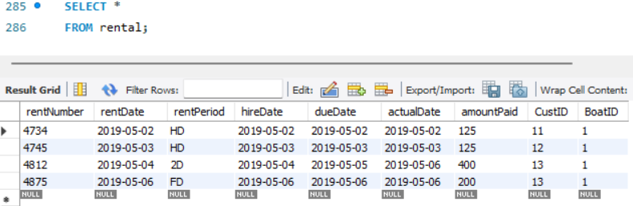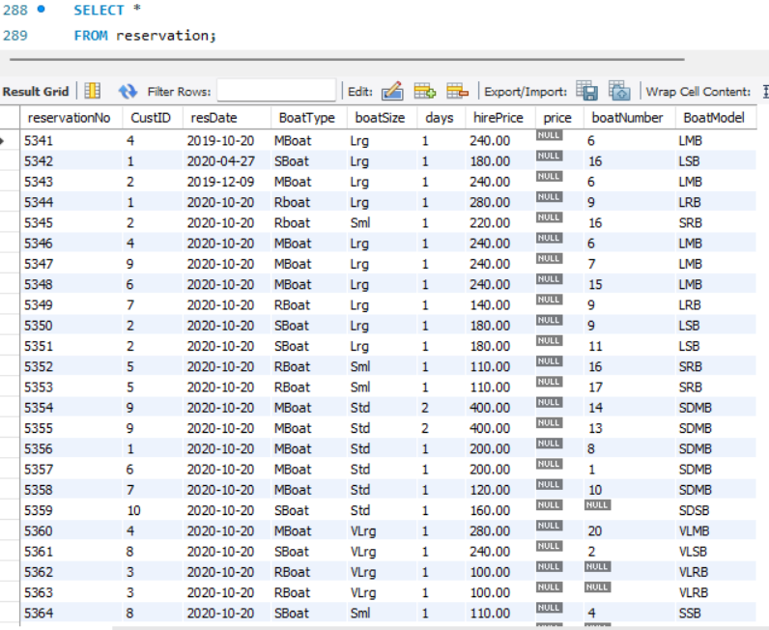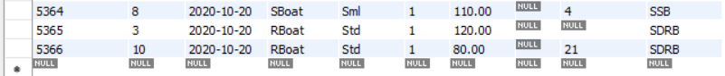

# Section 4: Student Statements

## Student A – Morgan Graves [21307114]

Through this project I learned the importance of both top-down and bottom-up data models to make an efficient ERD, in addition to learning the concepts of normalisation to produce a database to a high professional standard. I have also developed my understanding of SQL to create databases and insert the necessary data to create and efficient and professional database system.

## Student B – Clint Paris [20051828]

Throughout the project I have learned how to use SQL to create tables using code and to also find key pieces of information from those tables using SELECT codes amongst others. I have also learned how to create ERD’s, normalise ERD’s, Bottom Up ERD’s, & create Top Down ERD’s. In addition, I understand the importance of communicating effectively with the team to ensure everyone knows when the meetings are taking place and what I need to do in order to not fall behind deadline.

## Student C – David Tudorache [21302129]

I have learned how to design both a top-down and bottom-up ERD, as well as how to use that ERD to implement a SQL table. I also learned how to normalise a table of data and how to effectively communicate with my team.

## Student D – Fadumo Farah [21440542]

During the whole project I have learnt how to gather information use it to produce individual top-down ERD’s and then as a group come together and produce a group ERD, incorporating each other's ideas. Also, I have learnt how to use the data and turn it into a SQL table and produce information to discuss within my group.

# Appendix A: Individual ERD Attempts

**David Tudorache (21302129):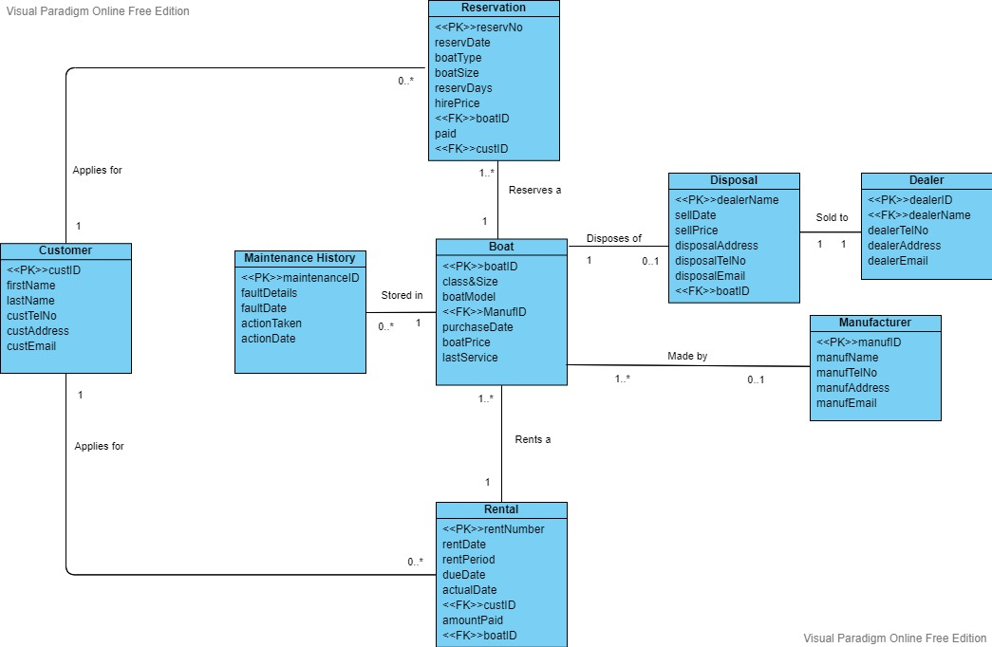Morgan Graves (21307114):**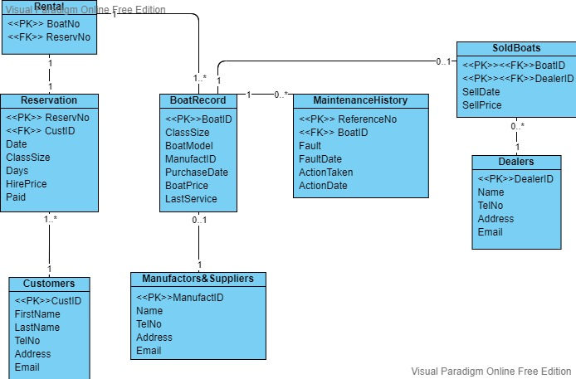

**Clint Paris(20051828):**

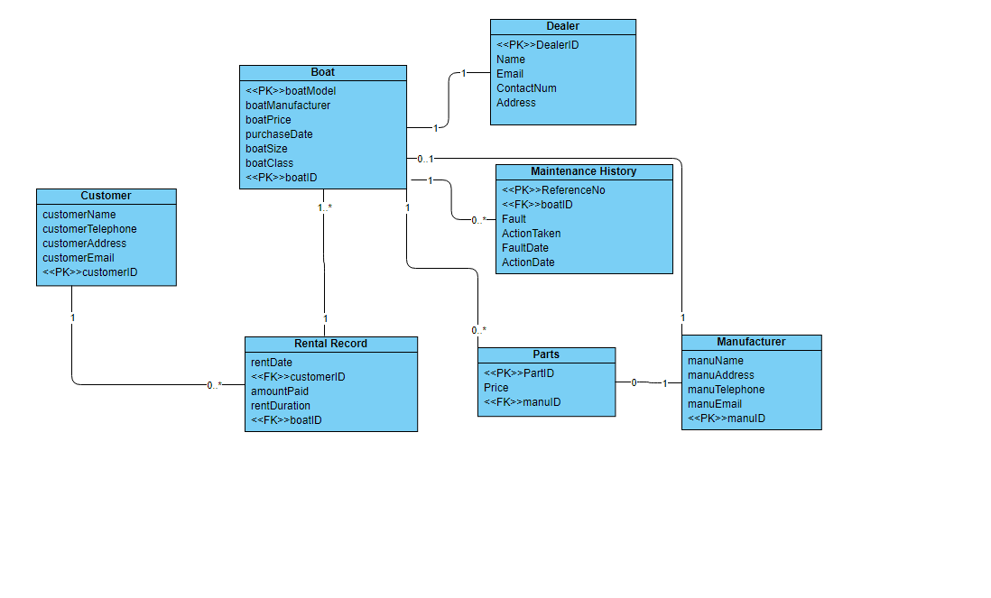**Fadumo Farah(21440542):**

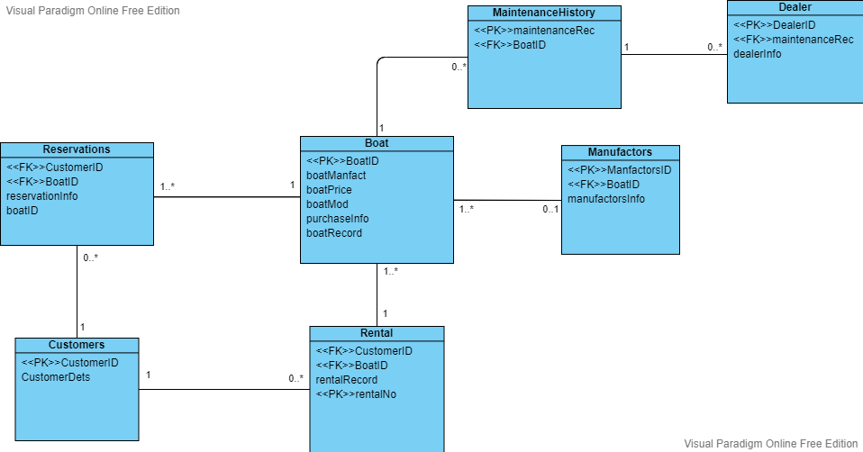

# Appendix B: Logbook

# Logbook Entry 1 - 03/02/2022

**Attendance:** All the computer database amigos are present!

We all discussed how we would attempt each individual ERD and have a meeting at the same time next week to combine them all.

Clint Paris: Work on individual top-down ERD

David Tudorache: Work on individual top-down ERD

Fadumo Farah: Work on individual top-down ERD

Morgan Graves: Work on individual top-down ERD

Next meeting: 10/02/2022

Homework: Work on individual ERD (possible normalisation included).

# Logbook Entry 2 - 10/02/2022

**Attendance:** Clint, David and Morgan Present

David and Morgan worked on combining the individual ERD's to make the first draft of the group one, we also assisted Clint on improvements on his individual one.

Clint Paris: Work on individual top down ERD

David Tudorache: Work on group top down ERD draft 1

Morgan Graves: Work on group top down ERD draft 1

**Absent:**

Fadumo Farah: Reason: Unknown

Next meeting: 17/02/2022

Homework for the 17th: Work on group ERD combination

Homework from the 10th: Both David and Morgan completed their individual top-down ERD, Clint needed assistance before uploading his. Fatima not present to review homework.

# Logbook Entry 3 - 17/02/2022

**Attendance:**

All of us present reviewed the group ERD, reviewed changes suggested by our tutor and asked for any additional feedback before making the final group top-down ERD. We had to make the final top-down ERD without combining Fatima's as it hasn't been uploaded yet and we didn't want to fall behind on time.

Clint Paris

David Tudorache

Morgan Graves

**Absent:**

Fadumo Farah: Reason: Late, however mentioned she will upload individual ERD this week

Next Meeting: 22.02.2022 [12:00]

Homework for 22nd: Normalisation/Bottom-Up Design

Homework from 17th: The group top-down ERD was completed and any further adjustments were made in the following lab thanks to feedback from the tutor.

# Logbook Entry 4 22/02/22

**Attendance:**

David Tudorache

Morgan Graves

**Absent:**

Clint Paris: Reason: Absent due to illness, hasn't completed normalization

Fadumo Farah: Reason: Unknown, hasn't completed normalization.

Next Meeting: 24.02.2022 [12:00]

Homework for 22nd: Completed by David and Morgan

Homework from 24th: Produce final ERD

# Logbook Entry 5 - 24.02.2022

**Attendance:**

David Tudorache

Morgan Graves

Clint Paris

Completed Final ERD

**Absent:**

Fadumo Farah: Reason: Unknown, hasn't completed normalization.

**Split SQL work:**

Clint: -Create parts table

-Create sold boats table and insert data (on some boat records and a seperate table)

-Create boat types and insert data (rental price table)

David: -Create boat record and insert data

-Create manufacture details and insert data

-Create maintenance table and insert data (data is on boat records)

Fatima: -Create partsforboats table

-Create dealers table and insert data

Morgan: -Create and insert customer data

-Create and insert rental record

-Create and insert reservation

# Logbook Entry 6 - 03/03/2022

**Attendance:**

David Tudorache

Morgan Graves

Clint Paris

Fadumo Farah (via video call)

**Split SQL work:**

Clint: -Create parts table: **COMPLETE**

-Create sold boats table and insert data (on some boat records and a seperate table): **COMPLETE**

-Create boat types and insert data (rental price table): **COMPLETE**

David: -Create boat record and insert data: **COMPLETE**

-Create manufacture details and insert data: **COMPLETE**

-Create maintenance table and insert data (data is on boat records): **COMPLETE**

Fadumo: -Create partsforboats table: **COMPLETE**

-Create dealers table and insert data: **Semi-complete, no data inserted. (Data for Details table finished by Clint)**

Morgan: -Create and insert customer data: **COMPLETE**

-Create and insert rental record: **COMPLETE**

-Create and insert reservation: **COMPLETE**

**Next Meeting Date: 10/03/2022 [1:30]**

**Combine SQL, complete report summary**

# Logbook Entry 7 [FINAL] - 10/03/2022

# Attendance:

David Tudorache

Morgan Graves

Clint Paris

Fadumah Farah

Everyone is present today, working on finishing the assignment by adding the final bits and pieces and ensuring everyone is happy with the submission.

Clint has added all the Logbook Entries onto the document and finished the student statement.

Morgan has added all the SQL onto the document and finished the student statement.

David has worked on the Summary and finished the student statement.

Fatima/Fadumah has helped edit the paragraph below the Top Down ERD and finished the student statement.

There are no more meeting after today as the module will be finished and all the work will be submitted.

# Appendix C: Full SQL Code

SET FOREIGN_KEY_CHECKS =0;

DROP TABLE emp;

DROP TABLE employees_teach;

DROP TABLE job_history;

DROP TABLE section;

DROP TABLE jobs;

DROP TABLE locations;

DROP TABLE regions;

DROP TABLE employees;

DROP TABLE departments;

DROP TABLE countries;

CREATE TABLE ManufactureDetails (

ManufID decimal(5,0) PRIMARY KEY,

ManufNam varchar(50) ,

ManufTelNo decimal(11,0) ,

ManufAddress varchar(50) ,

ManufPostCode varchar(8) ,

ManufEmail varchar(50)

);

CREATE TABLE Dealers (

DealerName varchar(50) PRIMARY KEY,

DealerTelNo varchar(50),

DealerAddress longtext,

DealerEmail longtext

);

CREATE TABLE BoatRecord (

BoatID decimal(5,0) PRIMARY KEY,

Class_Size varchar(11) ,

BoatModel varchar(25) ,

ManufID decimal(5,0) ,

PurchDate date ,

PurchPrice decimal(6,2) ,

LastService date ,

DealerName varchar(25) ,

SaleDate date ,

SalePrice decimal(6,2) ,

FOREIGN KEY (ManufID) REFERENCES ManufactureDetails (ManufID),

FOREIGN KEY (DealerName) REFERENCES Dealers (DealerName)

);

CREATE TABLE MaintenanceHistory (

MaintID decimal(5,0) PRIMARY KEY,

BoatID decimal(5,0) ,

MaintRefNo decimal(5,0) ,

FaultDetails varchar(50) ,

FaultDate date ,

ActionTaken varchar(50) ,

ActionDate date ,

FOREIGN KEY (`BoatID`) REFERENCES BoatRecord (`BoatID`)

);

CREATE TABLE BoatTypes(

BoatModel VARCHAR(25) PRIMARY KEY,

Class VARCHAR(25),

Size VARCHAR(25),

Price DECIMAL(65)

);

CREATE TABLE Parts(

PartID INT PRIMARY KEY,

ManufID decimal(5,0),

BoatID decimal(5,0),

Price INT,

QuantityOrdered INT,

QuantityInStock INT,

FOREIGN KEY (BoatID) REFERENCES BoatRecord (BoatID),

FOREIGN KEY (ManufID) REFERENCES ManufactureDetails (ManufID)

);

CREATE TABLE PartsForBoats(

PartID INT,

BoatID decimal(5,0),

CONSTRAINT PRIMARY KEY(PartID, BoatID),

FOREIGN KEY (BoatID) REFERENCES BoatRecord (BoatID),

FOREIGN KEY (PartID) REFERENCES Parts (PartID)

);

CREATE TABLE Customer

(CustID DECIMAL(4) PRIMARY KEY,

FirstName VARCHAR(25),

LastName VARCHAR(25),

CustTelNo DECIMAL(11),

CustAddress VARCHAR(255),

CustEmail VARCHAR(255));

CREATE TABLE SoldBoats(

BoatID decimal(5,0),

saleDate DATE,

price VARCHAR(25),

CONSTRAINT PRIMARY KEY(boatID, saleDate),

FOREIGN KEY (BoatID) REFERENCES BoatRecord (BoatID)

);

CREATE TABLE rental(

rentNumber INT PRIMARY KEY,

rentDate DATE,

rentPeriod VARCHAR(10),

hireDate DATE,

dueDate DATE,

actualDate DATE,

amountPaid INT,

CustID DECIMAL(4),

BoatID decimal(5,0),

FOREIGN KEY (BoatID) REFERENCES BoatRecord (BoatID),

FOREIGN KEY (CustID) REFERENCES Customer (CustID)

);

CREATE TABLE reservation(

reservationNo DECIMAL(10) PRIMARY KEY,

CustID DECIMAL(4),

resDate DATE,

BoatType VARCHAR(25),

boatSize VARCHAR(6),

days DECIMAL(1),

hirePrice DECIMAL(10,2),

price DECIMAL(10),

boatNumber DECIMAL(2),

BoatModel VARCHAR(25),

FOREIGN KEY (CustID) REFERENCES Customer (CustID),

FOREIGN KEY (BoatModel) REFERENCES BoatTypes (BoatModel)

);

INSERT INTO Dealers(DealerName, DealerAddress, DealerTelNo, DealerEmail)

VALUES('Dalis Vannoort', '77 A828, Appin, AP7 6GU', 075731374643, 'dvannoort0@salon.com');

INSERT INTO Dealers(DealerName, DealerAddress, DealerTelNo, DealerEmail)

VALUES('Joes Junk', '15 Back Lane, Buxton, BX7 5FY', 07365534221, 'JoesJunk@zdnet.com');

INSERT INTO Dealers(DealerName, DealerAddress, DealerTelNo, DealerEmail)

VALUES('Hoebart Kubera', '4 Finedon House, Marine Parade, Littlestone, LS4 6GU', 07874051869, 'hkubera2@who.int');

INSERT INTO Dealers(DealerName, DealerAddress, DealerTelNo, DealerEmail)

VALUES('Eva Iacomettii', '9 Hartlands, Onslow Road, Newent, NW5 8TU', 07880072148, 'eiacomettii3@admin.ch');

INSERT INTO Dealers(DealerName, DealerAddress, DealerTelNo, DealerEmail)

VALUES('Alley Pate', '07610 Arizona Alley, A67 8GU', 07822040557, 'apate4@gnu.org');

INSERT INTO Dealers(DealerName, DealerAddress, DealerTelNo, DealerEmail)

VALUES('Korrie Legge', '1076 Evesham Road, Astwood Bank, DT5 8JO', 07380018233, 'klegge5@reference.com');

INSERT INTO Dealers(DealerName, DealerAddress, DealerTelNo, DealerEmail)

VALUES('Minne Hinkens', '53 Balby Road, Balby, B7 8HK', 07978390430, 'mhinkens6@smh.com.au');

INSERT INTO Dealers(DealerName, DealerAddress, DealerTelNo, DealerEmail)

VALUES('Inigo MacAllaster', '1910 Farwell Plaza, G56 9FT', 07893419552, 'imacallaster7@blogspot.com' );

INSERT INTO Dealers(DealerName, DealerAddress, DealerTelNo, DealerEmail)

VALUES('Linell Skeeles', '57 Great Russell Street, London, NW1 8TU', 07532931207, 'lskeeles8@goo.gl');

INSERT INTO Dealers(DealerName, DealerAddress, DealerTelNo, DealerEmail)

VALUES('Sioux Drogan', '75 Thomas Parsons Square, Ely, EL6 9GU', 07417098738, 'sdrogan9@dropbox.com');

INSERT INTO ManufactureDetails

VALUES (1,'SuperBoat',1772459666,'Unit 7 Centurion Court, Leyland','LE10 2DJ','admin@superboat.co.uk'),

(2,'Explorer Boats UK',1704807654,'Meadow Lane, Burscough','BU56 8GH','admin@explorerboats.co.uk'),

(3,'The Northwich Boat Company',1270160160,'Unit 1 Kings Lock Boatyard Booth Lane, Middlewich','MW67 7GY','admin@northwichboats.co.uk'),

(4,'Collingwood Boat Builders',1513742985,'29 Townsend Street, Collingwood','CL27 2DU','admin@collingwoodboats.co.uk'),

(5,'Elton Moss Boat Builders',1270760160,'Unit 4 Kings Lock Boatyard Booth Lane, Middlewich','MW63 8TY','admin@eltonmossboats.co.uk'),

(6,'Aintree Boat Company Ltd',1515239000,'Brookfield Drive, Liverpool','L1 6GU','admin@aintreeboats.co.uk'),

(7,'Braidbar Boats Ltd',1625873471,'Lord Vernons Wharf Lyme Road Higher, Poynton','PY12 9TS','admin@braidbarboats.co.uk'),

(8,'Bourne Boat Builders Ltd ',1785714692,'Teddesley Road, Penkridge','PE8 7SU','admin@bourneboats.co.uk'),

(9,'Stoke on Trent Boat Building Co Ltd',1782813831,'Longport Wharf Station Street, Stoke-on-Trent','ST6 9GU','admin@stokeboats.co.uk'),

(10,'MGM Boats Narrowboat Builders',1162640009,'27 Mill Lane, Leicester','LE6 9FY','admin@mgmboats.co.uk');

INSERT INTO BoatTypes(boatModel, class, size, price)

VALUES('VLSB', 'sail boat', 'very large', 240);

INSERT INTO BoatTypes(boatModel, class, size, price)

VALUES('LSB', 'sail boat', 'large', 180);

INSERT INTO BoatTypes(boatModel, class, size, price)

VALUES('SDSB', 'sail boat', 'standard', 160);

INSERT INTO BoatTypes(boatModel, class, size, price)

VALUES('SSB', 'sail boat', 'small', 140);

INSERT INTO BoatTypes(boatModel, class, size, price)

VALUES('VLMB', 'motor boat', 'very large', 280);

INSERT INTO BoatTypes(boatModel, class, size, price)

VALUES('LMB', 'motor boat', 'large', 240);

INSERT INTO BoatTypes(boatModel, class, size, price)

VALUES('SDMB', 'motor boat', 'standard', 200);

INSERT INTO BoatTypes(boatModel, class, size, price)

VALUES('SMB', 'motor boat', 'small', 170);

INSERT INTO BoatTypes(boatModel, class, size, price)

VALUES('VLRB', 'row boat', 'very large', 160);

INSERT INTO BoatTypes(boatModel, class, size, price)

VALUES('LRB', 'row boat', 'large', 140);

INSERT INTO BoatTypes(boatModel, class, size, price)

VALUES('SDRB', 'row boat', 'standard', 120);

INSERT INTO BoatTypes(boatModel, class, size, price)

VALUES('sRB', 'row boat', 'small', 110);

INSERT INTO Customer(CustID, FirstName, LastName, CustTelNo, CustAddress, CustEmail)

VALUES (1, 'Dion', 'Broadnecke', 07174826351, '9 Oak Street, Liverpool, L34 8DY', 'dbroes1d@who.int');

INSERT INTO Customer(CustID, FirstName, LastName, CustTelNo, CustAddress, CustEmail)

VALUES (2, 'Scarlett', 'Galley', 03260476982, '886 Northport Parkway, Liverpool, L3 6DF', 'scargr1c@imgur.com');

INSERT INTO Customer(CustID, FirstName, LastName, CustTelNo, CustAddress, CustEmail)

VALUES (3, 'Sissy', 'Gadson', 04924556740, '95 Putney Road, Liverpool, L2 7YG', 'sgadson1b@ucoz.com');

INSERT INTO Customer(CustID, FirstName, LastName, CustTelNo, CustAddress, CustEmail)

VALUES (4, 'Tabby', 'Minichi', 07795213673, '6 Amoth Court, Warrington, WT6 8UY', 'minitabc@imgur.com');

INSERT INTO Customer(CustID, FirstName, LastName, CustTelNo, CustAddress, CustEmail)

VALUES (5, 'Nellie', 'Greenmon', 03816078215, '40 Graceland Crossing, Liverpool, L23 8FY', 'nelliegreen12@patch.com');

INSERT INTO Customer(CustID, FirstName, LastName, CustTelNo, CustAddress, CustEmail)

VALUES (6, 'Hanny', 'Marsters', 07075576685 , '2 Almo Trail, Liverpool, L21 9FY', 'hmarsters@netlog.com');

INSERT INTO Customer(CustID, FirstName, LastName, CustTelNo, CustAddress, CustEmail)

VALUES (7, 'Oswell', 'Aspinell', 09931348133 , '64 Jackson Road, Liverpool, L5 6FH', 'OsAspinell@digg.com');

INSERT INTO Customer(CustID, FirstName, LastName, CustTelNo, CustAddress, CustEmail)

VALUES (8, 'Florance', 'Baston', 07315082134, '40 Magdeline Lane, Warrington, WT5 8WK', 'FloBar@dirtg.com');

INSERT INTO Customer(CustID, FirstName, LastName, CustTelNo, CustAddress, CustEmail)

VALUES (9, 'Candice', 'Tumilson', 01639824657, '1 Farragut Parkway, Liverpool, L75 8GJ', 'canditum15@bloomberg.com');

INSERT INTO Customer(CustID, FirstName, LastName, CustTelNo, CustAddress, CustEmail)

VALUES (10, 'Clair', 'Bavin', 06245985897, '87 Toban Drive, Liverpool, L26 8GH', 'clairBav@sprog.it');

INSERT INTO Customer(CustID, FirstName, LastName, CustTelNo, CustAddress, CustEmail)

VALUES (11, 'John', 'Terry', 0201772227, 'SE10 1NH', 'Terry2D@ok.com');

INSERT INTO Customer(CustID, FirstName, LastName, CustTelNo, CustAddress, CustEmail)

VALUES (12, 'Justin', 'Bieber', 0167756413, 'LABC564', 'Beiber@pop.com');

INSERT INTO Customer(CustID, FirstName, LastName, CustTelNo, CustAddress, CustEmail)

VALUES (13, 'David', 'Hockney', 0154326412, 'N1 1XY', 'hockers@gall.com');

INSERT INTO Customer(CustID, FirstName, LastName, CustTelNo, CustAddress, CustEmail)

VALUES (14, 'David', 'Blaine',0154326412 , 'N1 1XY', 'blaine@magic.org');

INSERT INTO reservation(reservationNo, custID, resDate, boatType, boatSize,days, hirePrice, boatNumber, boatModel)

VALUES(5344, 1, '2020-10-20', 'Rboat', 'Lrg', 1, 280, 9, 'LRB');

INSERT INTO reservation(reservationNo, custID, resDate, boatType, boatSize,days, hirePrice, boatNumber, boatModel)

VALUES(5345, 2, '2020-10-20', 'Rboat', 'Sml', 1, 220, 16, 'SRB');

INSERT INTO reservation(reservationNo, custID, resDate, boatType, boatSize,days, hirePrice, boatNumber, boatModel)

VALUES(5347, 9, '2020-10-20', 'MBoat', 'Lrg', 1, 240, 7, 'LMB');

INSERT INTO reservation(reservationNo, custID, resDate, boatType, boatSize,days, hirePrice, boatNumber, boatModel)

VALUES(5346, 4, '2020-10-20', 'MBoat', 'Lrg', 1, 240, 6, 'LMB');

INSERT INTO reservation(reservationNo, custID, resDate, boatType, boatSize,days, hirePrice, boatNumber, boatModel)

VALUES(5349, 7, '2020-10-20', 'RBoat', 'Lrg', 1, 140, 9, 'LRB');

INSERT INTO reservation(reservationNo, custID, resDate, boatType, boatSize,days, hirePrice, boatNumber, boatModel)

VALUES(5348, 6, '2020-10-20', 'MBoat', 'Lrg', 1, 240, 15, 'LMB');

INSERT INTO reservation(reservationNo, custID, resDate, boatType, boatSize,days, hirePrice, boatNumber, boatModel)

VALUES(5350, 2, '2020-10-20', 'SBoat', 'Lrg', 1, 180, 9, 'LSB');

INSERT INTO reservation(reservationNo, custID, resDate, boatType, boatSize,days, hirePrice, boatNumber, boatModel)

VALUES(5352, 5, '2020-10-20', 'RBoat', 'Sml', 1, 110, 16, 'SRB');

INSERT INTO reservation(reservationNo, custID, resDate, boatType, boatSize,days, hirePrice, boatNumber, boatModel)

VALUES(5353, 5, '2020-10-20', 'RBoat', 'Sml', 1, 110, 17, 'SRB');

INSERT INTO reservation(reservationNo, custID, resDate, boatType, boatSize,days, hirePrice, boatNumber, boatModel)

VALUES(5354, 9, '2020-10-20', 'MBoat', 'Std', 2, 400, 14, 'SDMB');

INSERT INTO reservation(reservationNo, custID, resDate, boatType, boatSize,days, hirePrice, boatNumber, boatModel)

VALUES(5351, 2, '2020-10-20', 'SBoat', 'Lrg', 1, 180, 11, 'LSB');

INSERT INTO reservation(reservationNo, custID, resDate, boatType, boatSize,days, hirePrice, boatNumber, boatModel)

VALUES(5364, 8, '2020-10-20', 'SBoat', 'Sml', 1, 110, 4, 'SSB');

INSERT INTO reservation(reservationNo, custID, resDate, boatType, boatSize,days, hirePrice, boatNumber, boatModel)

VALUES(5355, 9, '2020-10-20', 'MBoat', 'Std', 2, 400, 13, 'SDMB');

INSERT INTO reservation(reservationNo, custID, resDate, boatType, boatSize,days, hirePrice, boatNumber, boatModel)

VALUES(5356, 1, '2020-10-20', 'MBoat','Std', 1, 200, 8, 'SDMB');

INSERT INTO reservation(reservationNo, custID, resDate, boatType, boatSize,days, hirePrice, boatNumber, boatModel)

VALUES(5357, 6, '2020-10-20', 'MBoat', 'Std', 1, 200, 1, 'SDMB');

INSERT INTO reservation(reservationNo, custID, resDate, boatType, boatSize,days, hirePrice, boatNumber, boatModel)

VALUES(5358, 7, '2020-10-20', 'MBoat', 'Std', 1, 120, 10, 'SDMB');

INSERT INTO reservation(reservationNo, custID, resDate, boatType, boatSize,days, hirePrice, boatNumber, boatModel)

VALUES(5366, 10, '2020-10-20', 'RBoat', 'Std', 0.5, 80, 21, 'SDRB');

INSERT INTO reservation(reservationNo, custID, resDate, boatType, boatSize,days, hirePrice, boatNumber, boatModel)

VALUES(5360, 4, '2020-10-20', 'MBoat', 'VLrg', 1, 280, 20, 'VLMB');

INSERT INTO reservation(reservationNo, custID, resDate, boatType, boatSize,days, hirePrice, boatNumber, boatModel)

VALUES(5361, 8, '2020-10-20', 'SBoat', 'VLrg', 1, 240, 2, 'VLSB');

INSERT INTO reservation(reservationNo, custID, resDate, boatType, boatSize,days, hirePrice, boatNumber, boatModel)

VALUES(5359, 10, '2020-10-20', 'SBoat', 'Std', 1, 160, null, 'SDSB');

INSERT INTO reservation(reservationNo, custID, resDate, boatType, boatSize,days, hirePrice, boatNumber, boatModel)

VALUES(5362, 3, '2020-10-20', 'RBoat', 'VLrg', 1, 100, null, 'VLRB');

INSERT INTO reservation(reservationNo, custID, resDate, boatType, boatSize,days, hirePrice, boatNumber, boatModel)

VALUES(5365, 3, '2020-10-20', 'RBoat','Std',1,120,null,'SDRB');

INSERT INTO reservation(reservationNo, custID, resDate, boatType, boatSize,days, hirePrice, boatNumber, boatModel)

VALUES(5363,3,'2020-10-20','RBoat','VLrg',1,100,null,'VLRB');

INSERT INTO reservation(reservationNo, custID, resDate, boatType, boatSize,days, hirePrice, boatNumber, boatModel)

VALUES(5342,1,'2020-04-27','SBoat','Lrg',1,180,16,'LSB');

INSERT INTO reservation(reservationNo, custID, resDate, boatType, boatSize,days, hirePrice, boatNumber, boatModel)

VALUES(5341,4,'2019-10-20','MBoat','Lrg',1,240,6,'LMB');

INSERT INTO reservation(reservationNo, custID, resDate, boatType, boatSize,days, hirePrice, boatNumber, boatModel)

VALUES(5343,2,'2019-12-09','MBoat','Lrg',1,240,6,'LMB');

INSERT INTO BoatRecord

VALUES (1,'Std_MBoat','Explorer',1,'2010-11-22',3910.00,'2020-10-22','Dalis Vannoort','2020-01-02',1500.00);

INSERT INTO BoatRecord

VALUES (2,'VLrg_SBoat','TurboSail',2,'2009-10-12',3840.00,'2019-10-08','Joes Junk','2019-10-10',1600.00);

INSERT INTO BoatRecord

VALUES (3,'Lrg_SBoat','MasterSail',2,'2009-10-12',3840.00,'2019-10-08',NULL,NULL,NULL);

INSERT INTO BoatRecord

VALUES(4,'Sml_SBoat','SmallSailor',3,'2015-11-12',2040.00,'2020-10-14',NULL,NULL,NULL),

(5,'Sml_SBoat','SmallSailor',3,'2015-11-12',2040.00,'2020-10-13',NULL,NULL,NULL),

(6,'Lrg_MBoat','Grande',5,'2015-01-14',5440.00,'2020-10-15',NULL,NULL,NULL),

(7,'Lrg_MBoat','Grande',5,'2015-01-14',5440.00,'2020-09-13',NULL,NULL,NULL),

(8,'Std_MBoat','Turbo Mid',2,'2015-01-14',5440.00,'2020-09-13',NULL,NULL,NULL),

(9,'Lrg_RBoat','RowStream',3,'2015-01-12',440.00,'2020-10-10',NULL,NULL,NULL),

(10,'Std_RBoat','RowerX',4,'2015-01-12',320.00,'2020-09-22',NULL,NULL,NULL),

(11,'Lrg_SBoat','Explorer',1,'2016-01-10',3320.00,'2020-03-03',NULL,NULL,NULL),

(12,'Std_SBoat','Navigator',1,'2016-01-10',3320.00,'2020-04-03',NULL,NULL,NULL),

(13,'Std_MBoat','Turbo Mid',2,'2018-02-14',4440.00,'2020-09-14',NULL,NULL,NULL),

(14,'Std_MBoat','Turbo Mid',2,'2018-02-14',4440.00,'2020-09-13',NULL,NULL,NULL),

(15,'Lrg_MBoat','MasterBlaster',7,'2018-02-14',5440.00,'2020-10-14',NULL,NULL,NULL),

(16,'Lrg_RBoat','HappyRower',8,'2018-01-10',340.00,'2020-10-02',NULL,NULL,NULL),

(17,'Sml_RBoat','HappyRower',8,'2018-01-10',340.00,'2020-10-02',NULL,NULL,NULL),

(18,'VLrg_RBoat','Streamer',3,'2017-01-09',640.00,'2020-10-07',NULL,NULL,NULL),

(19,'VLrg_RBoat','Great Row',4,'2019-01-19',650.00,'2020-09-12',NULL,NULL,NULL),

(20,'VLrg_MBoat','SuperBlaster',7,'2018-01-14',7440.00,'2020-08-07',NULL,NULL,NULL),

(21,'Std_RBoat','Lizard',6,'2017-01-09',340.00,'2020-10-04',NULL,NULL,NULL),

(22,'Lrg_MBoat','Grande',5,'2018-02-14',5440.00,'2020-09-13',NULL,NULL,NULL),

(23,'Lrg_SBoat','MasterSail',2,'2015-10-12',3240.00,'2020-01-27',NULL,NULL,NULL);

INSERT INTO MaintenanceHistory

VALUES (1,1,1,'Chipped propeller','2015-02-15','Replace Propeller','2015-02-27'),

(2,1,2,'Bilge pumps gone','2015-02-15','New bilge pumps','2015-08-27'),

(3,1,3,NULL,NULL,'New head pumps','2015-08-15'),

(4,1,4,NULL,NULL,'Normal Service','2016-03-20'),

(5,1,5,'Cutless bearing worn through','2016-12-02','Fit new bearing','2017-01-27'),

(6,3,1,'Damaged mast','2016-04-17','Repair Mast','2016-04-27'),

(7,3,2,'Bent Forestay','2017-07-10','Replace Forestay','2017-08-22'),

(8,3,3,'Shot Boom','2018-05-07','Replace Boom','2018-06-06'),

(9,3,4,'Rudderstock Chipped','2019-06-07','Repair Rudderstock','2019-06-08'),

(10,3,5,NULL,NULL,'Normal Service','2020-01-27'),(11,3,6,'Rudderblade busted','2020-10-19',NULL,NULL);

INSERT INTO SoldBoats(boatID, saleDate, price)

VALUES('1', '2020-11-30', 1500);

INSERT INTO SoldBoats(boatID, saleDate, price)

VALUES('3', '2020-01-02', 1500);

INSERT INTO SoldBoats(boatID, saleDate, price)

VALUES('2', '2019-10-10', 1600);

INSERT INTO rental(rentNumber, rentDate, rentPeriod, hireDate, dueDate, actualDate, amountPaid, custID, boatID)

VALUES(4734, '2019-05-02', 'HD', '2019-05-02', '2019-05-02', '2019-05-02', 125,11, 1);

INSERT INTO rental(rentNumber, rentDate, rentPeriod, hireDate, dueDate, actualDate, amountPaid, custID, boatID)

VALUES(4745, '2019-05-03', 'HD', '2019-05-03', '2019-05-03', '2019-05-03', 125,12, 1);

INSERT INTO rental(rentNumber, rentDate, rentPeriod, hireDate, dueDate, actualDate, amountPaid, custID, boatID)

VALUES(4812, '2019-05-04', '2D', '2019-05-04', '2019-05-05', '2019-05-06', 400,13, 1);

INSERT INTO rental(rentNumber, rentDate, rentPeriod, hireDate, dueDate, actualDate, amountPaid, custID, boatID)

VALUES(4875, '2019-05-06', 'FD', '2019-05-06', '2019-05-06', '2019-05-06', 200,13, 1);

SELECT *

FROM ManufactureDetails;

SELECT *

FROM Dealers;

SELECT *

FROM BoatRecord;

SELECT *

FROM MaintenanceHistory;

SELECT *

FROM BoatTypes;

SELECT *

FROM Customer;

SELECT *

FROM SoldBoats;

SELECT *

FROM rental;

SELECT *

FROM reservation;